Lab Session – Day 11

**Question:**

Use classicmodels. Create a procedure Get_Orders_Status which should accept the status value from user and show the number of orders for each year for that status.

The output should look as shown in below image.

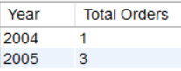 *Shipped Status Cancelled Status On Hold Status*

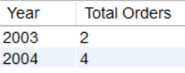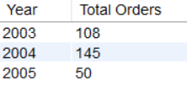

**Solution:**

Write the below query in MySQL workbench.

